## Life Process

### **Nutrition in Plants and Animals – Life Processes Class 10 Notes**

* **Nutrition:** The process by which an organism takes food and utilizes it, is called nutrition.
* **Need for Nutrition:** Organisms need the energy to perform various activities. The energy is supplied by the nutrients. Organisms need various raw materials for growth and repair. These raw materials are provided by nutrients.
* **Nutrients:** Materials which provide nutrition to organisms are called nutrients. Carbohydrates, proteins and fats are the main nutrients and are called macronutrients. Minerals and vitamins are required in small amounts and hence are called micronutrients.
* **Modes of Nutrition**  
  1. Autotrophic Nutrition.  
  2. Heterotrophic Nutrition.

**Autotrophic Nutrition – Life Processes Class 10 Notes**

The mode of nutrition in which an organism prepares its own food is called autotrophic nutrition. Green plants and blue-green algae follow the autotrophic mode of nutrition.

* The organisms which carry out autotrophic nutrition are called autotrophs (green plants).  
  Life Processes Class 10 Notes Science Chapter 6 1
* Autotrophic nutrition is fulfilled by the process, by which autotrophs intake CO2 and H2O, and convert these into carbohydrates in the presence of chlorophyll, sunlight is called photosynthesis.
* Equation  
  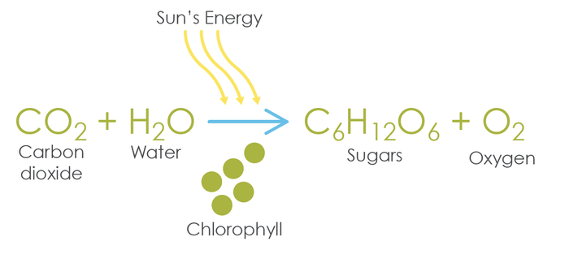

**Nutrition in Plants:** Green plants prepare their own food. They make food in the presence of sunlight. Sunlight provides energy’, carbon dioxide and water are the raw materials and chloroplast is the site where food is made.

### **What is Photosynthesis in biology class 10?**

**Photosynthesis:** The process by which green plants prepare food is called photosynthesis.

* During this process, the solar energy is converted into chemical energy and carbohydrates are formed.
* Green leaves are the main site of photosynthesis.
* The green portion of the plant contains a pigment chloroplast, chlorophyll (green pigment).
* The whole process of photosynthesis can be shown by the following equation:  
  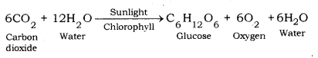

**Raw Materials for Photosynthesis:**

* Sunlight
* Chlorophyll: Sunlight absorbed by chloroplast
* CO2: Enters through stomata, and oxygen (O2) is released as a byproduct through stomata on the leaf.
* Water: Water + dissolved minerals like nitrogen, phosphorous etc., are taken up by the roots from the soil.

How do raw materials for photosynthesis become available to the plant?

* Water comes from the soil, through the xylem tissue in roots and stems.
* Carbon dioxide comes in the leaves through stomata.

**Site of Photosynthesis:** Chloroplast in the leaf. Chloroplast contains chlorophyll (green pigment)

**Main Events of Photosynthesis:**

* Absorption of light energy by chlorophyll.
* Conversion of light energy into chemical energy + splitting (breaking) of water into hydrogen and oxygen.
* Reduction of CO2 to carbohydrates.
* Sunlight activates chlorophyll, which leads to splitting of the water molecule.
* The hydrogen, released by the splitting of a water molecule is utilized for the reduction of carbon dioxide to produce carbohydrates.
* Oxygen is the by-product of photosynthesis.
* Carbohydrate is subsequently converted into starch and is stored in leaves and other storage parts.
* The splitting of water molecules is a part of the light reaction.

Other steps are part of the dark reaction during photosynthesis.  
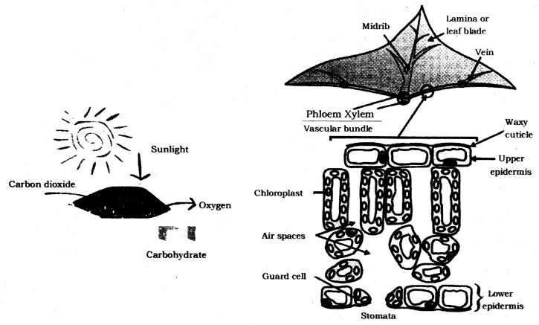

**Stomata – Life Processes Class 10 Notes**

* Stomata: These are tiny pores present in the epidermis of leaf or stem through which gaseous exchange and transpiration occur.

**Functions of stomata**

* Exchange of gases, O2 and CO2.
* Loses a large amount of water (water vapour) during transpiration.  
  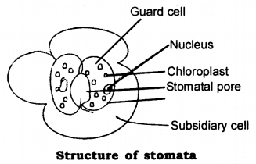

**Opening and closing of stomatal pores:**

* The opening and closing of stomatal pores are controlled by the turgidity of guard cells.
* When guard cells uptake water from surrounding cells, they swell to become a turgid body, which enlarges the pore in between (Stomatal Opening).
* While, when water is released, they become flaccid shrinking to close the pore (Stomatal Closing).  
  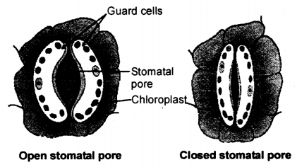

**Significance of Photosynthesis:**

* Photosynthesis is the main way through which solar energy is made available for different living beings.
* Green plants are the main producers of food in the ecosystem. All other organisms directly or indirectly depend on green plants for food.
* The process of photosynthesis also helps in maintaining the balance of carbon dioxide and oxygen in the air.

**Heterotrophic Nutrition – Life Processes Class 10 Notes**

The mode of nutrition in which an organism takes food from another organism is called heterotrophic nutrition. Organisms, other than green plants and blue-green algae follow the heterotrophic mode of nutrition. Heterotrophic nutrition can be further divided into three types, viz. saprophytic nutrition, holozoic nutrition, and parasitic.

* **Saprophytic Nutrition:** In saprophytic nutrition, the organism secretes the digestive juices on the food. The food is digested while it is still to be ingested. The digested food is then ingested by the organism. All the decomposers follow saprophytic nutrition. Some insects, like houseflies, also follow this mode of nutrition.
* **Holozoic Nutrition:** In holozoic nutrition, the digestion happens inside the body of the organism. i.e., after the food is ingested. Most of the animals follow this mode of nutrition.
* **Parasitic Nutrition:** The organism which lives inside or outside another organism (host) and derives nutrition from it is known as parasites and this type of mode of nutrition is called parasitic nutrition. For example Cuscuta, tick etc.

**Nutrition in Amoeba**

* Amoeba is a unicellular animal which follows the holozoic mode of nutrition.
* In holozoic nutrition, the digestion of food follows after the ingestion of food. Thus, digestion takes place inside the body of the organism.
* Holozoic nutrition happens in five steps, viz. ingestion, digestion, absorption, assimilation and egestion.  
  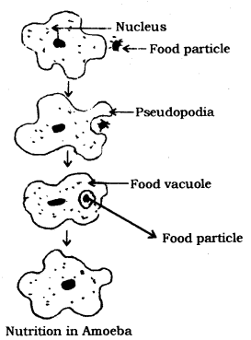

**Steps of Holozoic Nutrition:**

* Ingestion: The process of taking in the food is called ingestion.
* Digestion: The process of breaking complex food substances into simple molecules is called digestion. Simple molecules, thus obtained, can be absorbed by the body.
* Absorption: The process of absorption of digested food is called absorption.
* Assimilation: The process of utilization of digested food, for energy and for growth and repair is called assimilation.
* Egestion: The process of removing undigested food from the body is called egestion.

Amoeba is a unicellular animal which follows the holozoic mode of nutrition. The cell membrane of amoeba keeps on protruding into pseudopodia. Amoeba surrounds a food particle with pseudopodia and makes a food vacuole. The food vacuole contains food particle and water. Digestive enzymes are secreted in the food vacuole and digestion takes place. After that, digested food is absorbed from the food vacuole. Finally, the food vacuole moves near the cell membrane and undigested food is expelled out.

### **Nutrition in Human Beings – Life Processes Class 10 Notes**

Human beings are complex animals, which have a complex digestive system. The human digestive system is composed of an alimentary canal and some accessory glands. The alimentary canal is divided into several parts, like oesophagus, stomach, small intestine, large intestine, rectum and anus. Salivary gland, liver and pancreas are the accessory glands which lie outside the alimentary canal.

**Structure of the Human Digestive System:**The human digestive system comprises of the alimentary canal and associated digestive glands.

* Alimentary Canal: It comprises of mouth, oesophagus, stomach, small intestine and large intestine.
* Associated Glands: Main associated glands are
  + Salivary gland
  + Gastric Glands
  + Liver
  + Pancreas

**Mouth or Buccal Cavity:**

* The mouth has teeth and tongue. Salivary glands are also present in the mouth.
* The tongue has gustatory receptors which perceive the sense of taste.
* The tongue helps in turning over the food so that saliva can be properly mixed in it.
* Teeth help in breaking down the food into smaller particles so that, swallowing of food becomes easier.
* There are four types of teeth in human beings. The incisor teeth are used for cutting the food.
* The canine teeth are used for tearing the food and for cracking hard substances.
* The premolars are used for the coarse grinding of food. The molars are used for fine grinding of food.  
  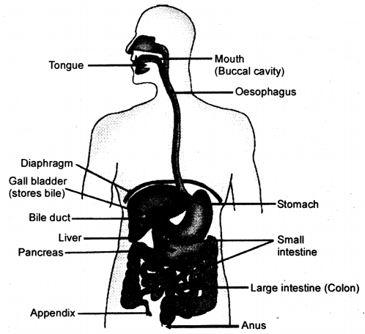

**Salivary glands secrete saliva**: Saliva makes the food slippery which makes it easy to swallow the food. Saliva also contains the enzyme salivary amylase or ptyalin. Salivary amylase digests starch and converts it into sucrose, (maltose).  
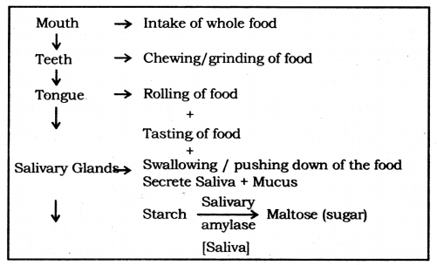

**Oesophagus:** Taking food from mouth to stomach by Peristaltic movement.

**Peristaltic movement:** Rhythmic contraction of muscles of the lining of the alimentary canal to push the food forward.

**Stomach**

* Stomach is a bag-like organ. Highly muscular walls of the stomach help in churning the food.
* The walls of the stomach secrete hydrochloric acid. Hydrochloric acid kills the germs which may be present in food.
* Moreover, it makes the medium inside the stomach as acidic. The acidic medium is necessary for gastric enzymes to work.
* The enzyme pepsin, secreted in the stomach, does partial digestion of protein.
* The mucus, secreted by the walls of the stomach saves the inner lining of the stomach from getting damaged from hydrochloric acid.  
  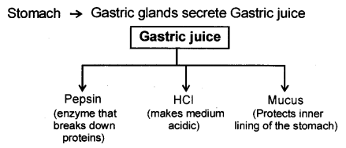

**Small Intestine:** It is a highly coiled tube-like structure. The small intestine is longer than the large intestine but its lumen is smaller than that of the large intestine. The small intestine is divided into three parts, like duodenum, jejunum and ileum.

**Liver:** Liver is the largest organ in the human body. The liver manufactures bile, which gets stored in the gall bladder. From the gall bladder, bile is released as and when required.

**Pancreas:** Pancreas is situated below the stomach. It secretes pancreatic juice which contains many digestive enzymes.  
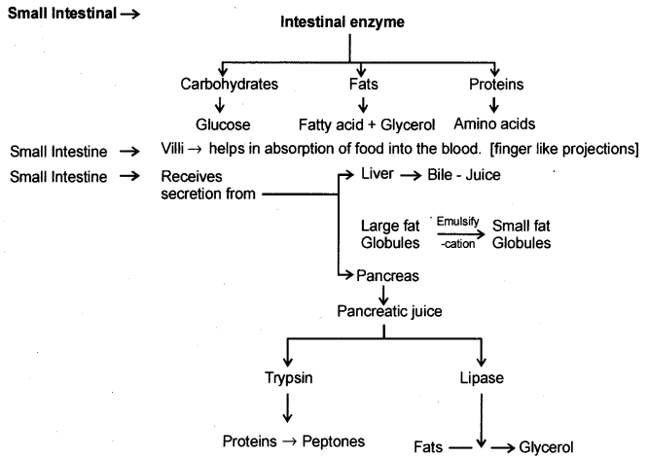  
Bile and pancreatic juice go to the duodenum through a hepatopancreatic duct. Bile breaks down fat into smaller particles. This process is called emulsification of fat. After that, the enzyme lipase digests fat into fatty acids and glycerol. Trypsin and chymotrypsin are enzymes which digest protein into amino acids. Complex carbohydrates are digested into glucose. The major part of digestion takes place in the duodenum.

**No digestion takes place in the jejunum**: The inner wall in the ileum is projected into numerous finger-like structures, called villi. Villi increase the surface area inside the ileum so that optimum absorption can take place. Moreover, villi also reduce the lumen of the ileum so that food can stay for a longer duration in it, for optimum absorption. Digested food is absorbed by villi.

**Large Intestine:**

* Large intestine is smaller than the small intestine.
* Undigested food goes into the large intestine.
* Some water and salt are absorbed by the walls of the large intestine. After that, the undigested food goes to the rectum, from where it is expelled out through the anus.
* Large Intestine bbsorb excess of water. The rest of the material is removed from the body via the anus. (Egestion).

### **Respiration – Life Processes Class 10 Notes**

Types of respiration, aerobic and anaerobic respiration, human respiratory system, respiration in plants.

**Respiration:** The process by which a living being utilises the food to get energy, is called respiration. Respiration is an oxidation reaction in which carbohydrate is oxidized to produce energy. Mitochondria is the site of respiration and the energy released is stored in the form of ATP (adenosine triphosphate). ATP is stored in mitochondria and is released as per need.

### **Steps of respiration:**

* **Breaking down of glucose into pyruvate:** This step happens in the cytoplasm. Glucose molecule is broken down into pyruvic acid. Glucose molecule is composed of 6 carbon atoms, while pyruvic acid is composed of 3 carbon atoms.
* **Fate of Pyruvic Acid:** Further breaking down of pyruvic acid takes place in mitochondria and the molecules formed depend on the type of respiration in a particular organism. Respiration is of two types, viz. aerobic respiration and anaerobic respiration.
* **Respiration involves**
  + Gaseous exchange: Intake of oxygen from the atmosphere and release of CO2 → Breathing.
  + Breakdown of simple food in order to release energy inside the cell → Cellular respiration

### **Types of Respiration – Life Processes Class 10 Notes**

* **Aerobic respiration:** This type of respiration happens in the presence of oxygen. Pyruvic acid is converted into carbon dioxide. Energy is released and water molecule is also formed at the end of this process.
* **Anaerobic respiration:** This type of respiration happens in the absence of oxygen. Pyruvic acid is either converted into ethyl alcohol or lactic acid. Ethyl alcohol is usually formed in case of anaerobic respiration in microbes, like yeast or bacteria. Lactic acid is formed in some microbes as well as in the muscle cells.
  + Glucose (6 carbon molecule) → Pyruvate (3 carbon molecules) + Energy
  + Pyruvate (In yeast, lack of O2) → Ethyl alcohol + Carbon dioxide + Energy
  + Pyruvate (In muscles, lack of O2) → Lactic Acid + Energy
  + Pyruvate (In mitochondria; the presence of O2) → Carbon dioxide + Water + Energy

The equations for the above reactions can be written as follows:  
Life Processes Class 10 Notes Science Chapter 6 11  
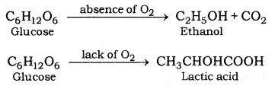  
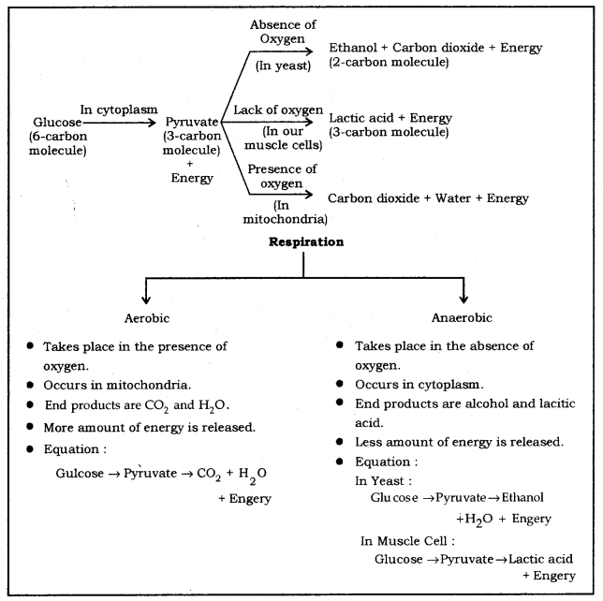

**Pain in leg muscles while running:**

* When someone runs too fast, he may experience throbbing pain in the leg muscles. This happens because of anaerobic respiration taking place in the muscles.
* During running, the energy demand from the muscle cells increases. This is compensated by anaerobic respiration and lactic acid is formed in the process.
* The deposition of lactic acid causes pain in the leg muscles. The pain subsides after taking rest for some time.

**Exchange of gases:**

* For aerobic respiration, organisms need a continuous supply of oxygen, and carbon dioxide produced during the process needs to be removed from the body.
* Different organisms use different methods for the intake of oxygen and expulsion of carbon dioxide.
* Diffusion is the method which is utilized by unicellular and some simple organisms for this purpose.
* In plants also, diffusion is utilized for exchange of gases.
* In complex animals, respiratory system does the job of exchange of gases.
* Gills are the respiratory organs for fishes. Fishes take in oxygen which is dissolved in water through gills.
* Since, availability of oxygen is less in the aquatic environment, so the breathing rate of aquatic organisms is faster.
* Insects have a system of spiracles and trachease which is used for taking in oxygen.
* Terrestrial organisms have developed lungs for exchange of gases.
* Availability of oxygen is not a problem in the terrestrial environment so breathing rate is slower as compared to what it is in fishes.

Terrestrial organisms: Use atmospheric oxygen for respiration.  
Aquatic organisms: Use dissolve oxygen for respiration.

**Human respiratory system – Life Processes Class 10 Notes**

The human respiratory system is composed of a pair of lungs. These are attached to a system of tubes which open on the outside through the nostrils.  
Following are the main structures in the human respiratory system:

1. Nostrils: There are two nostrils which converge to form a nasal passage. The inner lining of the nostrils is lined by hair and remains wet due to mucus secretion. The mucus and the hair help in filtering the dust particles out from inhaled air. Further, air is warmed up when it enters the nasal passage.
2. Pharynx: It is a tube-like structure which continues after the nasal passage.
3. Larynx: This part comes after the pharynx. This is also called voice box.
4. Trachea: This is composed of rings of cartilage. Cartilaginous rings prevent the collapse of trachea in the absence of air.
5. Bronchi: A pair of bronchi comes out from the trachea, with one bronchus going to each lung.
6. Bronchioles: A bronchus divides into branches and sub-branches inside the lung.
7. Alveoli: These are air sacs at the end of bronchioles. The alveolus is composed of a very thin membrane and is the place where blood capillaries open. This is alveolus, where the oxygen mixes with the blood and carbon dioxide exits from the blood. The exchange of gases, in alveoli, takes place due to the pressure differential.

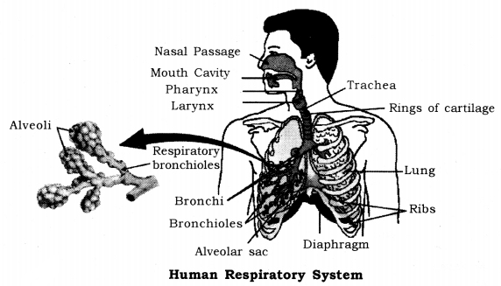

Passage of air through the respiratory system in human beings:  
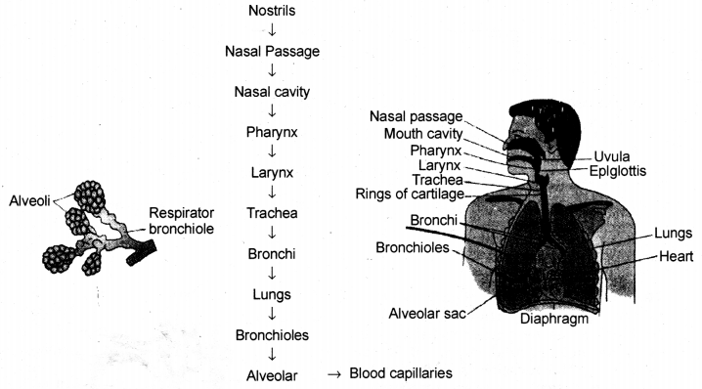

**Breathing Mechanism**

* The breathing mechanism of lungs is controlled by the diaphragm and the intercostalis muscles.
* The diaphragm is a membrane which separates the thoracic chamber from the abdominal cavity.
* When the diaphragm moves down, the lungs expand and the air is inhaled.
* When the diaphragm moves up, the lungs contract and air are exhaled.

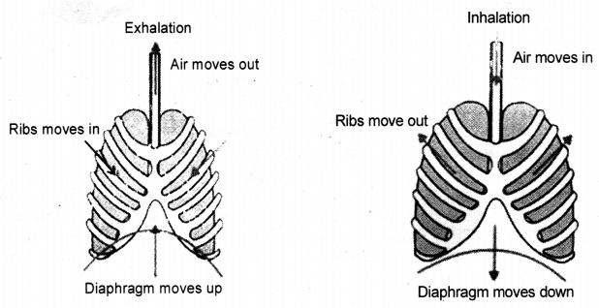  
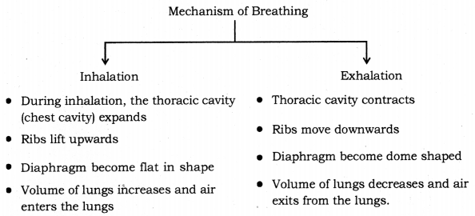

### **Transportation – Life Processes Class 10 Notes**

Circulatory system of human being, transportation in plants. Human beings like other multicellular organism need a regular supply of foods, oxygen etc. This function is performed by a circulatory system or transport system.

**Transportation in Human Beings:** The circulatory system is responsible for transport of various substances in human beings. It is composed of the heart, arteries, veins and blood capillaries. Blood plays the role of the carrier of substances.  
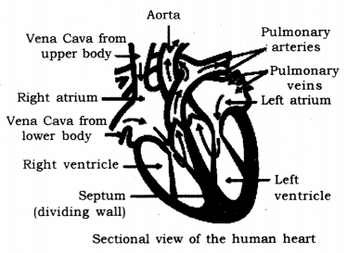

**1. Heart:** Heart is a muscular organ, which is composed of cardiac muscles.

* It is so small that, it can fit inside an adult’s wrist. The heart is a pumping organ which pumps the blood.
* The human heart is composed of four chambers, viz. right atrium, right ventricle, left ventricle and left atrium.
* Systole: Contraction of cardiac muscles is called systole.
* Diastole: Relaxation of cardiac muscles is called diastole.

**2. Arteries:**

* These are thick-walled blood vessels which carry oxygenated blood from the heart to different organs.
* Pulmonary arteries are exceptions because they carry deoxygenated blood from the heart to lungs, where oxygenation of blood takes place.

**3. Veins:**

* These are thin-walled blood vessels which carry deoxygenated blood from different organs to the heart, pulmonary veins are exceptions because they carry oxygenated blood from lungs to the heart.
* Valves are present in veins to prevent back flow of blood.

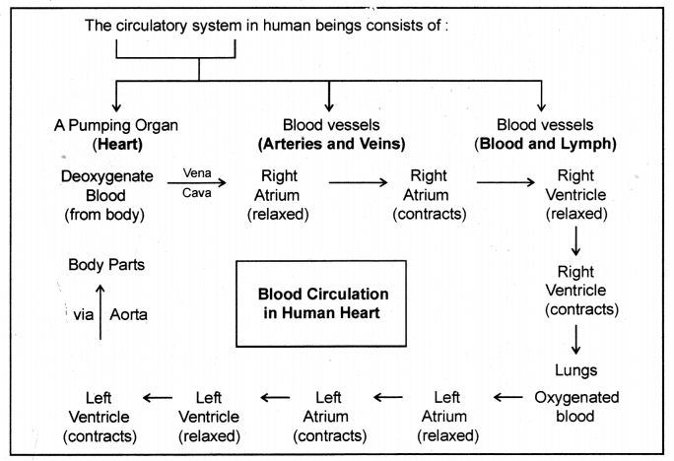

**4. Capillaries:** These are the blood vessels which have single-celled walls.

**Blood:** Blood is a connective tissue which plays the role of the carrier for various substances in the body. Blood is composed of 1. Plasma 2. Blood cells 3. Platelets.

* **Blood plasma:** Blood plasma is a pale coloured liquid which is mostly composed of water. Blood plasma forms the matrix of blood.
* **Bloods cells:** There are two types of blood cells, viz. Red Blood Cells (RBCs) and White Blood Cells (WBCs).  
  (a) Red Blood Corpuscles (RBCs): These are of red colour because of the presence of haemoglobin which is a pigment. Haemoglobin readily combines with oxygen and carbon dioxide. The transport of oxygen happens through haemoglobin. Some part of carbon dioxide is also transported through haemoglobin.  
  (b) White Blood Corpuscles (WBCs): These are of pale white colour. They play important role in the immunity.
* **Platelets:** Platelets are responsible for blood coagulation. Blood coagulation is a defense mechanism which prevents excess loss of blood, in case of an injury.

**Lymph:**

* Lymph is similar to blood but RBCs are absent in lymph.
* Lymph is formed from the fluid which leaks from blood capillaries and goes to the intercellular space in the tissues. This fluid is collected through lymph vessels and finally return to the blood capillaries.
* Lymph also plays an important role in the immune system.
* Lymph a yellowish fluids escape from the blood capillaries into the intercellular spaces contain less proteins than blood.
* Lymph flows from the tissues to the heart assisting in transportation and destroying germs.

**Double circulation:** In the human heart, blood passes through the heart twice in one cardiac cycle. This type of circulation is called double circulation. One complete heartbeat in which all the chambers of the heart contract and relax once is called cardiac cycle. The heart beats about 72 times per minute in a normal adult. In one cardiac cycle, the heart pumps out 70 mL blood and thus, about 4900 mL blood in a minute. Double circulation ensures complete segregation of oxygenated and deoxygenated blood which is necessary for optimum energy production in warm-blooded animals.  
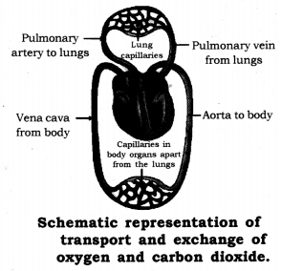

**Transportation in plants:** Plants have specialized vascular tissues for transportation of substances. There are two types of vascular tissues in plants.

* **Xylem:** Xylem is responsible for transportation of water and minerals. It is composed of trachids, xylem vessels, xylem parenchyma and xylem fibre. Tracheids and xylem vessels are the conducting elements. The xylem makes a continuous tube in plants which runs from roots to stem and right up to the veins of leaves.
* Carry water and minerals from the leaves to the other part of the plant.
* **Phloem:** Phloem is responsible for transportation of food. Phloem is composed of sieve tubes, companion cells, phloem parenchyma and bast fibers. Sieve tubes are the conducting elements in phloem.
* Carries product of photosynthesis from roots to other part of the plant.

Transportation in plants  
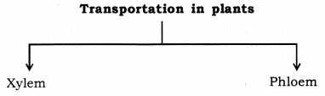

**Ascent of sap:** The upward movement of water and minerals from roots to different plant parts is called ascent of sap. Many factors are at play in ascent of sap and it takes place in many steps. They are explained as follows :

* Root pressure: The walls of cells of root hairs are very thin. Water from soil enters the root hairs because of osmosis. Root pressure is responsible for movement of water up to the base of the stem.
* Capillary action: A very fine tube is called capillaiy, water, or any liquid, rises in the capillary because of physical forces and this phenomenon is called capillary action. Water, in stem, rises up to some height because of capillaiy action.
* Adhesion-cohesion of water molecules: Water molecules make a continuous column in the xylem because of forces of adhesion and cohesion among the molecules.
* Transpiration pull: Loss of water vapour through stomata and lenticels, in plants, is called transpiration. Transpiration through stomata creates vacuum which creates a suction, called transpiration pull. The transpiration pull sucks the water column from the xylem tubes and thus, water is able to rise to great heights in even the tallest plants.
* **Transport of food:**Transport of food in plants happens because of utilization of energy. Thus, unlike the transport through xylem, it is a form of active transport. Moreover, the flow of substances through phloem takes place in both directions, i.e., it is a two-way traffic in phloem.  
  Transpiration is the process of loss of water as vapour from aerial parts of the plant.

**Functions**

* Absorption and upward movement of water and minerals by creating pull.
* Helps in temperature regulation in plant.

Transport of food from leaves (food factory) to different parts of the plant is called Translocation.

### **Excretion – Life Processes Class 10 Notes**

Human excretory system, excretion in plants.

**Excretion in human beings:**

* Removal of harmful waste from the body is called excretion.
* Many wastes are produced during various metabolic activities.
* These need to be removed in time because their accumulation in the body can be harmful and even lethal for an organism.

**Human Excretory System:**

* The human excretory system is composed of a pair of kidneys.
* A tube, called ureter, comes out of each kidney and goes to the urinary bladder.
* Urine is collected in the urinary bladder, from where it is expelled out through urethra as and when required.

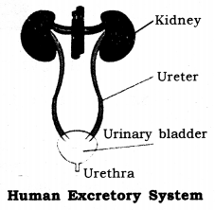

Excretory system of human beings includes :

* A pair of kidneys.
* A urinary bladder.
* A pair of the ureter.
* A urethra.

**Kidney:**

* Kidney is a bean-shaped organ which lies near the vertebral column in the abdominal cavity.
* The kidney is composed of many filtering units, called nephrons.
* Nephron is called the functional unit of kidney.

**Nephron**

* It is composed of a tangled mess of tubes and a filtering part, called glomerulus.
* The glomerulus is a network of blood capillaries to which renal artery is attached.
* The artery which takes blood to the glomerulus is called afferent arteriole and the one receiving blood from the glomerulus is called efferent arteriole.
* The glomerulus is enclosed in a capsule like portion, called bowman’s capsule. The bowman’s capsule extends into a fine tube which is highly coiled.
* Tubes from various nephrons converge into collecting duct, which finally goes to the ureter.

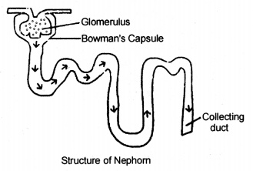

**Urine formation in the kidney:** The urine formation involves three steps:

* Glomerular filtration: Nitrogenous wastes, glucose, water, amino acid filter from the blood into bowman’s capsule of the nephron.
* Tubular reabsorption: Now, useful substances from the filtrate are reabsorbed back by capillaries surrounding the nephron.
* Secretion: Extra water, salts are secreted into the tubule which opens up into the collecting duct and then into the ureter.

Urine produced in the kidneys passes through the ureters into the urinary bladder where it is stored until it is released through the urethra.  
The purpose of making urine is to filter out waste product from the blood i.e., urea which is produced in the liver.

**Haemodialysis:** The process of purifying blood by an artificial kidney. It is meant for kidney failure patient.

**Excretion in Plants**  
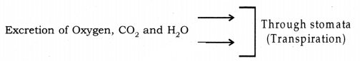

* Other wastes may be stored in leaves, bark etc. which fall off from the plant.
* Plants excrete some waste into the soil around them.
* Gums, resin → In old xylem
* Some metabolic wastes in the form of crystals of calcium oxalates in the leaves of colocasia and stem of Zamikand.

**Nutrition in Plants and Animals**

**Nutrition:** Process of obtaining and utilizing of food is known as nutrition.

**Mode of nutrition:**

* Autotrophic Nutrition (All green plants)
* Heterotrophic Nutrition (Animals, Man, Non-green plants)
  + Saprotrophic nutrition
  + Parasitic nutrition
  + Holozoic nutrition

**Autotrophs:** It is a mode of nutrition in which organisms can make their own food from simple raw material. Example, all green plants.

**Heterotrophs:** It is a mode of nutrition in which organisms cannot prepare their food on their own and depend on others. Example, animals.

**Saprotrophic Nutrition:** It is the process by which the organism feeds on dead and decaying matter. Example, Rhizopus, Mucor, yeast.

**Photosynthesis:** It is the process by which green plants prepare their own food.

**Raw materials for photosynthesis:**

* **Water and Minerals:** These are absorbed by the roots from the soil.
* **Carbon dioxide:** Carbon dioxide enters the leaves through tiny pores called stomata.
* **Sunlight:** Energy from the sun is called solar energy.
* **Chlorophyll:** Chlorophyll pigment helps leaves to capture solar energy.

**Products of Photosynthesis:** Carbohydrate-glucose- It is converted to starch.

**Symbiotic relationship:** Two organisms live in a close association and develop a relationship that is beneficial to both this is called a symbiotic relationship.  
Example, Lichen is a living partnership between a fungus an alga. Fungus absorbs water and provides shelter and alga prepare food by photosynthesis

**Insectivores:** Plants feed on insects for their nitrogen requirements.

**Holozoic nutrition:** It means feeding on solid food. Organism takes complex organic food into the body. Example, man, amoeba, dog, etc.

* **Herbivores:** Animals which feed on plants only. Example, deer, cow.
* **Carnivores:** Animals which feed on flesh or meat. Example, tiger.
* **Omnivores:** Animals which feed on both plant and flesh. Example, man, dog.

**Steps of Holozoic nutrition:**

* **Ingestion:** Taking food into the mouth.
* **Digestion:** Break down of large insoluble food into small water-soluble molecules by enzymes.
* **Absorption:** Digested food absorbed through the intestinal wall into the blood.
* **Assimilation:** Absorbed food is taken by body cells for releasing energy, growth and repair.
* **Egestion:** Eliminating undigested food from the body.

**Digestive organs of human beings:** Mouth, oesophagus, stomach, small intestine and large intestine with glands like salivary gland, liver, pancreas.

**Teeth:** An organ which breaks down the complex food and helps in chewing the food.

* **Milk teeth:** The first set of 20 small teeth when the baby is 6-7 months old.
* **Permanent teeth:** The second set of 32 larger teeth, when a child is 6-7 years old and comes by replacing milk teeth.

**Enamel:** A white, strong, shining, protective material covering on teeth.

**Tongue:** A muscular organ attached to the floor of the buccal cavity which helps in tasting and mixing the food with saliva for digestion.

**Transportation in Plants and Animals**

* **Vascular tissue:** A plant tissue which helps in transportation.
* **Xylem tissue:** It helps in transporting water and minerals in plants.
* **Phloem:** It helps in transporting food in plants.
* **Translocation:** The process of transporting food from leaves to other parts of plants.
* **Transpiration:** A loss of water from stomata in leaves.
* **Blood:** A red colour fluid which circulates in the body of animals.
* **Plasma:** Fluid part of the blood which consists of nutrients, hormones, and waste products.
* **Blood vessel:** Tube-like structure present in the body for carrying blood inside the body.
* **Artery:** It carries oxygenated blood from the heart to body parts.
* **Vein:** It carries deoxygenated blood from body parts to the heart.
* **Capillary:** A thin-walled narrow tube which connects artery and vein.
* **Heart:** A muscular organ present in the thoracic cavity and helps in pumping blood in the body.
* **Double circulation:** A circulatory system in which blood travels twice through the heart in one complete cycle.
* **Heartbeat:** One complete contraction and relaxation of the heart (72 times in a minute).
* **Stethoscope:** Instrument which measures heartbeat.
* **Systolic pressure:** Maximum pressure at which blood flows during contraction of the heart. (120 mm Hg)
* **Diastolic pressure:** Minimum pressure at which blood flows during relaxation of the heart. (80 mm Hg)
* **Sphygmomanometer:** Instrument which measures blood pressure.
* **Lymph:** A light yellow liquid flowing from body tissue to the blood circulatory system and provides immunity.

**Excretion in Plants and Animals**

* **Excretion:** It is the process of removing waste products from the body.
* **Excretory products of plants:** CO2, O2, water vapour, peel of bark, fruits, leaves, gum, raisin, etc.
* **Excretory products of humans:** Carbon dioxide, urea, etc.
* **Kidney:** Organ which removes the toxic substance urea from blood and filters it.
* **Urine:** A yellowish liquid which contains water and urea.
* **Dialysis:** The procedure used for cleaning the blood of a person in case of kidney failure.
* **Nephron:** Functional unit of excretory system present in the kidney for filtering blood.
* **Renal Artery:** Blood vessels which bring blood from heart to kidney.
* **Renal Vein:** Blood vessel which brings blood from kidney to heart.